Coding Our First Neurons
Given to single neuron
inputs = [1, 2, 3]
weights = [0.2, 0.8, -0.5]
bias = 2
This neuron sums each input multiplied by that input’s weight, then adds the bias. All the neuron does is take the fractions of inputs, where these fractions (weights) are the adjustable parameters, and adds another adjustable parameter — the bias — then outputs the result. Our output would be calculated up to this point like:

output = (inputs[0]*weights[0] + inputs[1]*weights[1] + inputs[2]*weights[2] + bias(

A Layer of Neurons :-
inputs = [ 1 , 2 , 3 , 2.5 ]

weights1 = [ 0.2 , 0.8 , - 0.5 , 1 ]
weights2 = [ 0.5 , - 0.91 , 0.26 , - 0.5 ]
weights3 = [ - 0.26 , - 0.27 , 0.17 , 0.87 ]
bias1 = 2
bias2 = 3
bias3 = 0.5
outputs = [
# Neuron 1:
inputs[ 0 ] * weights1[ 0 ] +
inputs[ 1 ] * weights1[ 1 ] +
inputs[ 2 ] * weights1[ 2 ] +
inputs[ 3 ] * weights1[ 3 ] + bias1,
# Neuron 2:
inputs[ 0 ] * weights2[ 0 ] +
inputs[ 1 ] * weights2[ 1 ] +
inputs[ 2 ] * weights2[ 2 ] +
inputs[ 3 ] * weights2[ 3 ] + bias2,
# Neuron 3:
inputs[ 0 ] * weights3[ 0 ] +
inputs[ 1 ] * weights3[ 1 ] +
inputs[ 2 ] * weights3[ 2 ] +
inputs[ 3 ] * weights3[ 3 ] + bias3]
output:- [ 4.8 , 1.21 , 2.385 ]

In this code, we have three sets of weights and three biases, which define three neurons. Each neuron is “connected” to the same inputs. The difference is in the separate weights and bias
that each neuron applies to the input. This is called a fully connected neural network — every neuron in the current layer has connections to every neuron from the previous layer.

we could use a loop to scale and handle dynamically-sized inputs and layers. We’ve turned the separate weight variables into a list of weights so we can iterate over them, and we changed the code to use loops instead of the hardcoded operations

:-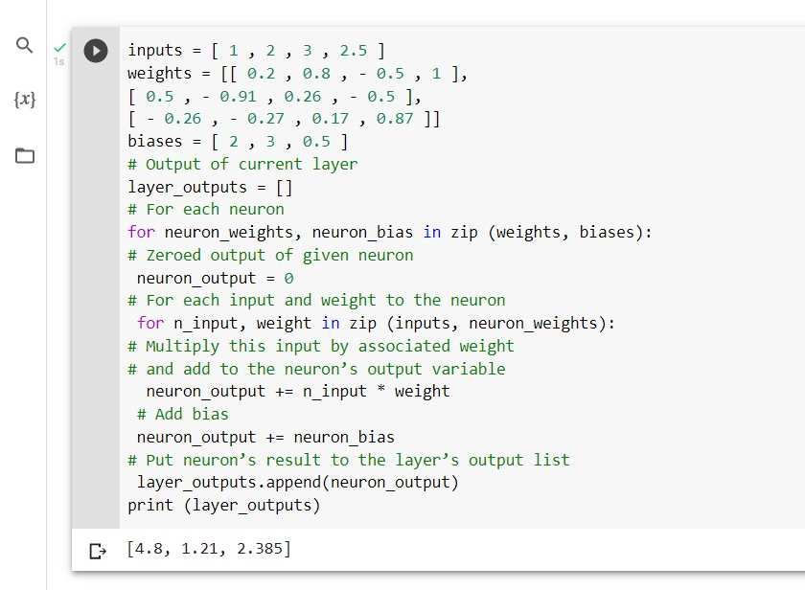
How a dot product is calculated in Python. For it, you have two vectors, which we
can represent as lists in Python. We then multiply their elements from the same index values and
then add all of the resulting products. Say we have two lists acting as our vectors:
a = [ 1 , 2 , 3 ]
b = [ 2 , 3 , 4 ]

To obtain the dot product:
dot_product = a[ 0 ] * b[ 0 ] + a[ 1 ] * b[ 1 ] + a[ 2 ] *b[ 2 ]
print (dot_product)
The result is a vector calculated as a sum of the consecutive vector elements:
A Single Neuron with NumPy
import numpy as np
inputs = [ 1.0 , 2.0 , 3.0 , 2.5 ]
weights = [ 0.2 , 0.8 , - 0.5 , 1.0 ]
bias = 2.0
outputs = np.dot(weights, inputs) + bias
print (outputs)

A Layer of Neurons with NumPy :-

Previously, we had calculated outputs of each neuron by performing a dot product and adding a
bias, one by one. Now we have changed the order of those operations — we’re performing dot
product first as one operation on all neurons and inputs, and then we are adding a bias in the next
operation. When we add two vectors using NumPy, each i-th element is added together, resulting
in a new vector of the same size. This is both a simplification and an optimization, giving us
simpler and faster code.

import numpy as np
inputs = [ 1.0 , 2.0 , 3.0 , 2.5 ]
weights = [[ 0.2 , 0.8 , - 0.5 , 1 ],
[ 0.5 , - 0.91 , 0.26 , - 0.5 ],
[ - 0.26 , - 0.27 , 0.17 , 0.87 ]]
biases = [ 2.0 , 3.0 , 0.5 ]
layer_outputs = np.dot(weights, inputs) + biases
print (layer_outputs)

A Batch of Data

To train, neural networks tend to receive data in batches. So far, the example input data have been only one sample (or observation ) of various features called a feature set:
inputs = [ 1 , 2 , 3 , 2.5 ]
Here, the [ 1 , 2 , 3 , 2.5 ] data are somehow meaningful and descriptive to the output we
desire. Imagine each number as a value from a different sensor, from the example in chapter 1 .

neural networks expect to take in many samples at a time for two reasons. One reason
- is that it’s faster to train in batches in parallel processing, and the other reason is that batches
help with generalization during training. If you fit (perform a step of a training process) on one
sample at a time, you’re highly likely to keep fitting to that individual sample, rather than
slowly producing general tweaks to weights and biases that fit the entire dataset. Fitting or
training in batches gives you a higher chance of making more meaningful changes to weights
and biases. For the concept of fitment in batches rather than one sample at a time, the
following animation can help:
Watch this:- https://nnfs.io/vyu/
A Layer of Neurons & Batch of Data w/ NumPy
Initially, we were able to perform the dot product on the inputs and the weights without a
transposition because the weights were a matrix, but the inputs were just a vector. In this case, the dot product results in a vector of atomic dot products performed on each row from the matrix and this single vector. When inputs become a batch of inputs (a matrix), we need to perform the matrix product. It takes all of the combinations of rows from the left matrix and columns from the right matrix, performing the dot product on them and placing the results in an output array. Both arrays have the same shape, but, to perform the matrix product, the shape’s value from the index 1 of the first matrix and the index 0 of the second matrix must match — they don’t right now.

If we transpose the second array, values of its shape swap their positions
The resulting matrix consists of outputs of all neurons after operations
performed on each input sample:

We can code this solution using NumPy now. We can perform np.dot() on a plain Python list of
lists as NumPy will convert them to matrices internally. We are converting weights ourselves
though to perform transposition operation first, T in the code, as plain Python list of lists does not
support it. Speaking of biases, we do not need to make it a NumPy array for the same reason —
NumPy is going to do that internally.

Biases are a list, though, so they are a 1D array as a NumPy array. The addition of this bias vector to a matrix (of the dot products in this case) works similarly to the dot product of a matrix and
vector that we described earlier; The bias vector will be added to each row vector of the matrix.
Since each column of the matrix product result is an output of one neuron, and the vector is going to be added to each row vector, the first bias is going to be added to each first element of those
vectors, second to second, etc. That’s what we need — the bias of each neuron needs to be added
to all of the results of this neuron performed on all input vectors (samples).

End of Chapter ----------------- summaries by eman shehta.

